However when trying to copy a series, then paste special, the paste special menu for setting the frequency conversion is not the usual one.

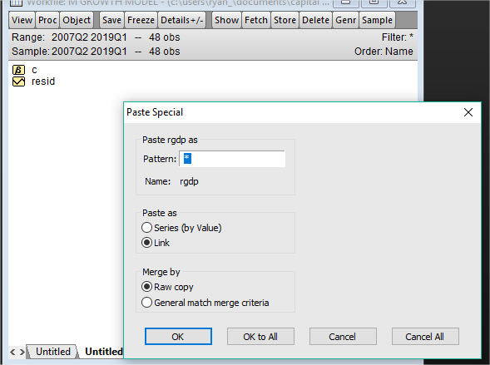

The correct one, per the instruction manual looks like this



