I would like to replicate a method of performance persistence to basically see how my data differs
Do., Faff R., Veeraraghavanc M. (2010) "Performance persistence in hedge funds: Australian evidence" Int. Fin. Markets, Inst. and Money 20 (2010) 346–362
Can someone please explain to me the following?
Here is the method description:
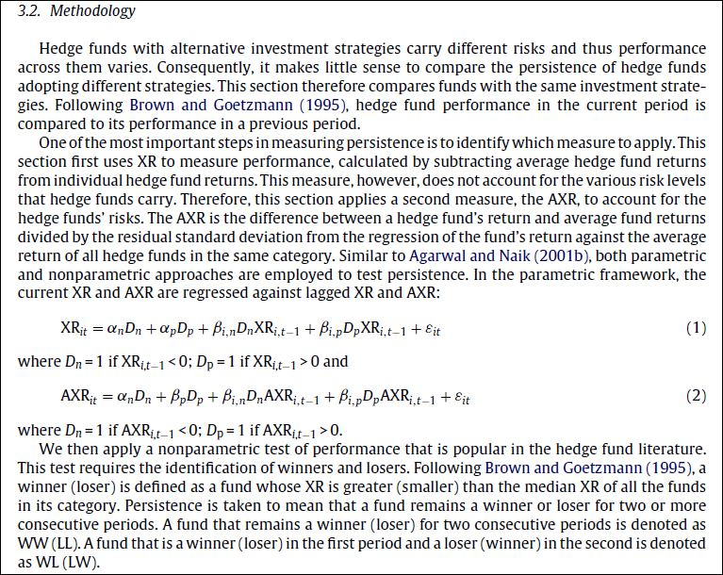

Here is the description of the results (from the same paper under the same method - I thought it might be helpful):

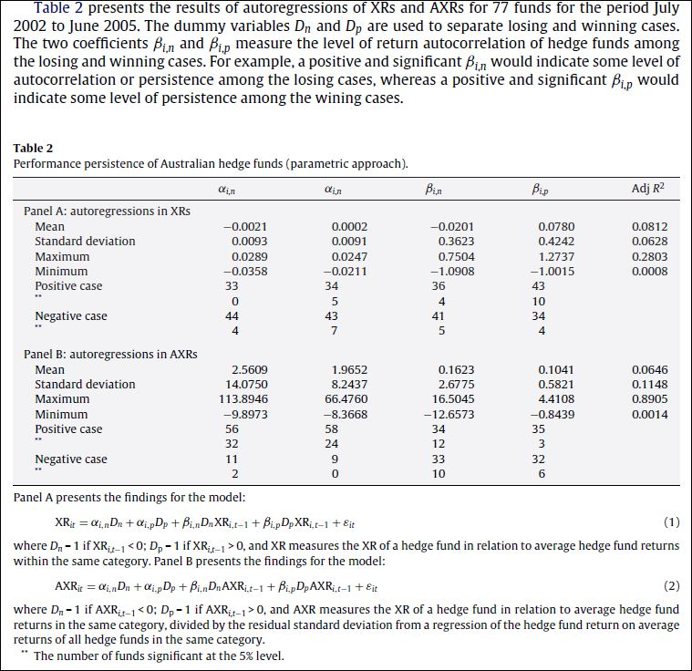

Here is the insight into what the data is like:
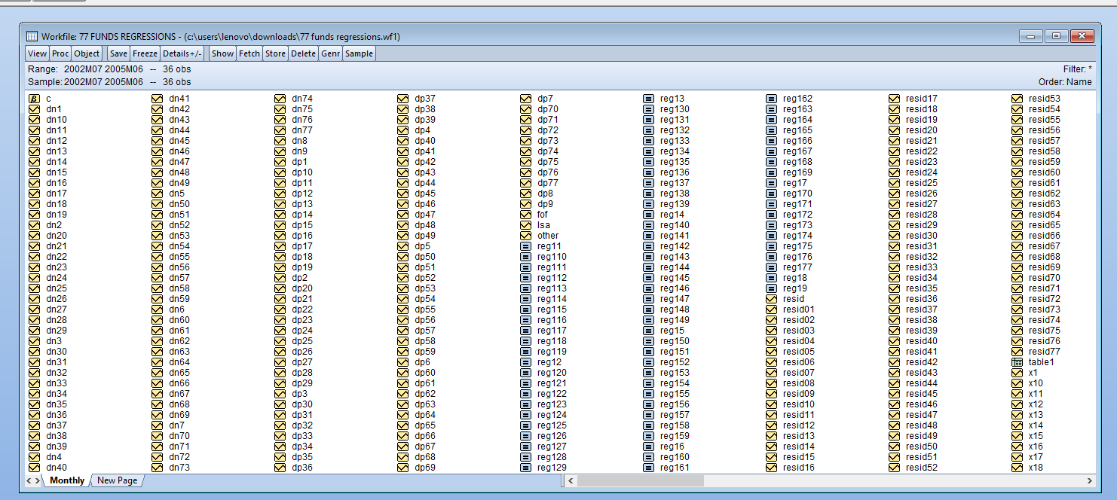
The example of one of the “analysed funds”
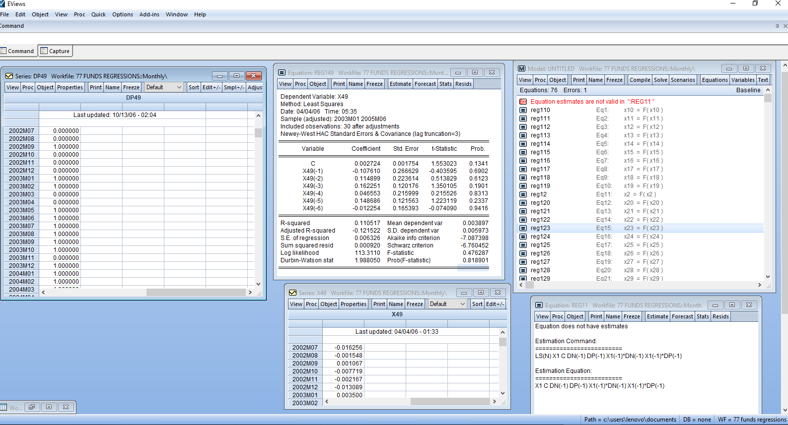
Closer screenshot of the results:
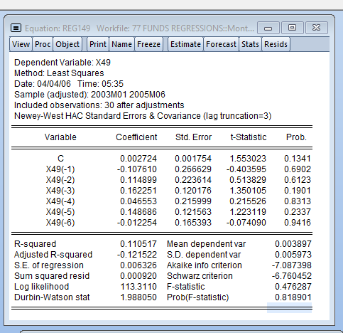
Raw figures of the results:

Dependent Variable: X49
Method: Least Squares
Date: 04/04/06 Time: 05:35
Sample (adjusted): 2003M01 2005M06
Included observations: 30 after adjustments
Newey-West HAC Standard Errors & Covariance (lag truncation=3)
Variable | Coefficient | Std. Error | t-Statistic | Prob.
C | 0.002724 | 0.001754 | 1.553023 | 0.1341
X49(-1) | -0.107610 | 0.266629 | -0.403595 | 0.6902
X49(-2) | 0.114899 | 0.223614 | 0.513829 | 0.6123
X49(-3) | 0.162251 | 0.120176 | 1.350105 | 0.1901
X49(-4) | 0.046553 | 0.215999 | 0.215526 | 0.8313
X49(-5) | 0.148686 | 0.121563 | 1.223119 | 0.2337
X49(-6) | -0.012254 | 0.165393 | -0.074090 | 0.9416
R-squared | 0.110517 | Mean dependent var |  | 0.003897
Adjusted R-squared | -0.121522 | S.D. dependent var |  | 0.005973
S.E. of regression | 0.006326 | Akaike info criterion |  | -7.087398
Sum squared resid | 0.000920 | Schwarz criterion |  | -6.760452
Log likelihood | 113.3110 | F-statistic |  | 0.476287
Durbin-Watson stat | 1.988050 | Prob(F-statistic) |  | 0.818901
Here is the equation that has been coded for regression number 1 or 11 / not sure how it was coded exactly as the author doesn’t remember himself:

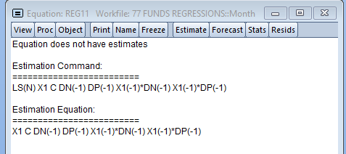
For example, it seems there’s some error in the REG11 equation.
Equation does not have estimates

Estimation Command:
=========================
LS(N) X1 C DN(-1) DP(-1) X1(-1)*DN(-1) X1(-1)*DP(-1)

Estimation Equation:
=========================
X1 C DN(-1) DP(-1) X1(-1)*DN(-1) X1(-1)*DP(-1)

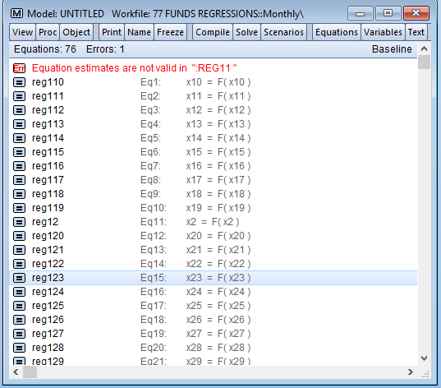

Raw data from the screenshot for DP49 Data:

2002M07 | 0
2002M08 | 0
2002M09 | 1
2002M10 | 0
2002M11 | 0
2002M12 | 0
2003M01 | 1
2003M02 | 1
2003M03 | 0
2003M04 | 0
2003M05 | 1
2003M06 | 1
2003M07 | 1
2003M08 | 1
2003M09 | 1
2003M10 | 1
2003M11 | 0
2003M12 | 1
2004M01 | 1
2004M02 | 1
2004M03 | 1
2004M04 | 1
2004M05 | 1
2004M06 | 1
2004M07 | 0
2004M08 | 1
2004M09 | 1
2004M10 | 1
2004M11 | 1
2004M12 | 1
2005M01 | 1
2005M02 | 1
2005M03 | 0
2005M04 | 0
2005M05 | 0
2005M06 | 1

Raw data from the screenshot for X49 Data:

2002M07 | -0.0163
2002M08 | -0.0015
2002M09 | 0.0011
2002M10 | -0.0077
2002M11 | -0.0022
2002M12 | -0.0131
2003M01 | 0.0035
2003M02 | 0.0052
2003M03 | -0.0062
2003M04 | -0.0043
2003M05 | 0.0061
2003M06 | 0.0072
2003M07 | 0.0107
2003M08 | 0.0103
2003M09 | 0.0012
2003M10 | 0.0166
2003M11 | -0.0049
2003M12 | 0.0154
2004M01 | 0.0044
2004M02 | 0.0023
2004M03 | 0.0079
2004M04 | 0.0038
2004M05 | 0.0051
2004M06 | 0.0143
2004M07 | -0.0006
2004M08 | 0.0058
2004M09 | 0.0068
2004M10 | 0.0040
2004M11 | 0.0011
2004M12 | 0.0022
2005M01 | 0.0037
2005M02 | 0.0062
2005M03 | -0.0058
2005M04 | -0.0052
2005M05 | -0.0008
2005M06 | 0.0011

Screenshot of the C (constant?) data

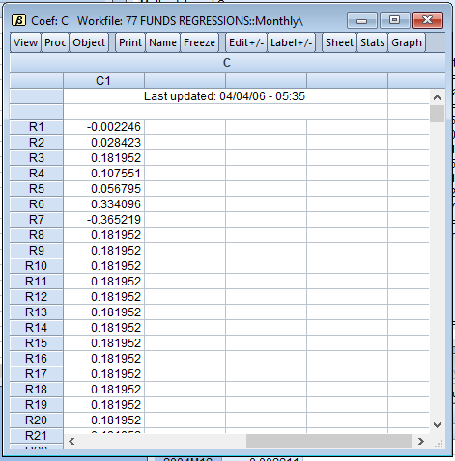
Raw Data for it:
R1 | -0.00225
R2 | 0.02842
R3 | 0.18195
R4 | 0.10755
R5 | 0.05680
R6 | 0.33410
R7 | -0.36522
R8 | 0.18195
R9 | 0.18195
R10 | 0.18195
R11 | 0.18195
R12 | 0.18195
R13 | 0.18195
R14 | 0.18195
R15 | 0.18195
R16 | 0.18195
R17 | 0.18195
R18 | 0.18195
R19 | 0.18195
R20 | 0.18195
R21 | 0.18195
R22 | 0.18195
R23 | 0.18195
R24 | 0.18195
R25 | 0.18195
R26 | 0.18195
R27 | 0.18195
R28 | 0.18195
R29 | 0.18195
R30 | 0.18195
R31 | 0.18195
R32 | 0.18195
R33 | 0.18195
R34 | 0.18195
R35 | 0.18195
R36 | 0.18195
R37 | 0.18195
R38 | 0.18195
R39 | 0.18195
R40 | 0.18195
R41 | 0.18195
R42 | 0.18195
R43 | 0.18195
R44 | 0.18195
R45 | 0.18195
R46 | 0.18195
R47 | 0.18195
R48 | 0.18195
R49 | 0.18195
R50 | 0.18195
R51 | 0.18195
R52 | 0.18195
R53 | 0.18195
R54 | 0.18195
R55 | 0.18195
R56 | 0.18195
R57 | 0.18195
R58 | 0.18195
R59 | 0.18195
R60 | 0.18195
R61 | 0.18195
R62 | 0.18195
R63 | 0.18195
R64 | 0.18195
R65 | 0.18195
R66 | 0.18195
R67 | 0.18195
R68 | 0.18195
R69 | 0.18195
R70 | 0.18195
R71 | 0.18195
R72 | 0.18195
R73 | 0.18195
R74 | 0.18195
R75 | 0.18195
R76 | 0.18195
R77 | 0.18195
R78 | 0.18195
R79 | 0.18195
R80 | 0.18195
R81 | 0.18195
R82 | 0.18195
R83 | 0.18195
R84 | 0.18195
R85 | 0.18195
R86 | 0.18195
R87 | 0.18195
R88 | 0.18195
R89 | 0.18195
R90 | 0.18195
R91 | 0.18195
R92 | 0.18195
R93 | 0.18195
R94 | 0.18195
R95 | 0.18195
R96 | 0.18195
R97 | 0.18195
R98 | 0.18195
R99 | 0.18195
R100 | 0.00000
R101 | 0.00000
R102 | 0.00000
R103 | 0.00000
R104 | 0.00000
R105 | 0.00000
R106 | 0.00000
R107 | 0.00000
R108 | 0.00000
R109 | 0.00000
R110 | 0.00000
R111 | 0.00000
R112 | 0.00000
R113 | 0.00000
R114 | 0.00000
R115 | 0.00000
R116 | 0.00000
R117 | 0.00000
R118 | 0.00000
R119 | 0.00000
R120 | 0.00000
R121 | 0.00000
R122 | 0.00000
R123 | 0.00000
R124 | 0.00000
R125 | 0.00000
R126 | 0.00000
R127 | 0.00000
R128 | 0.00000
R129 | 0.00000
R130 | 0.00000
R131 | 0.00000
R132 | 0.00000
R133 | 0.00000
R134 | 0.00000
R135 | 0.00000
R136 | 0.00000
R137 | 0.00000
R138 | 0.00000
R139 | 0.00000
R140 | 0.00000
R141 | 0.00000
R142 | 0.00000
R143 | 0.00000
R144 | 0.00000
R145 | 0.00000
R146 | 0.00000
R147 | 0.00000
R148 | 0.00000
R149 | 0.00000
R150 | 0.00000
R151 | 0.00000
R152 | 0.00000
R153 | 0.00000
R154 | 0.00000
R155 | 0.00000
R156 | 0.00000
R157 | 0.00000
R158 | 0.00000
R159 | 0.00000
R160 | 0.00000
R161 | 0.00000
R162 | 0.00000
R163 | 0.00000
R164 | 0.00000
R165 | 0.00000
R166 | 0.00000
R167 | 0.00000
R168 | 0.00000
R169 | 0.00000
R170 | 0.00000
R171 | 0.00000
R172 | 0.00000
R173 | 0.00000
R174 | 0.00000
R175 | 0.00000
R176 | 0.00000
R177 | 0.00000
R178 | 0.00000
R179 | 0.00000
R180 | 0.00000
R181 | 0.00000
R182 | 0.00000
R183 | 0.00000
R184 | 0.00000
R185 | 0.00000
R186 | 0.00000
R187 | 0.00000
R188 | 0.00000
R189 | 0.00000
R190 | 0.00000
R191 | 0.00000
R192 | 0.00000
R193 | 0.00000
R194 | 0.00000
R195 | 0.00000
R196 | 0.00000
R197 | 0.00000
R198 | 0.00000
R199 | 0.00000
R200 | 0.00000
R201 | 0.00000
R202 | 0.00000
R203 | 0.00000
R204 | 0.00000
R205 | 0.00000
R206 | 0.00000
R207 | 0.00000
R208 | 0.00000
R209 | 0.00000
R210 | 0.00000
R211 | 0.00000
R212 | 0.00000
R213 | 0.00000
R214 | 0.00000
R215 | 0.00000
R216 | 0.00000
R217 | 0.00000
R218 | 0.00000
R219 | 0.00000
R220 | 0.00000
R221 | 0.00000
R222 | 0.00000
R223 | 0.00000
R224 | 0.00000
R225 | 0.00000
R226 | 0.00000
R227 | 0.00000
R228 | 0.00000
R229 | 0.00000
R230 | 0.00000
R231 | 0.00000
R232 | 0.00000
R233 | 0.00000
R234 | 0.00000
R235 | 0.00000
R236 | 0.00000
R237 | 0.00000
R238 | 0.00000
R239 | 0.00000
R240 | 0.00000
R241 | 0.00000
R242 | 0.00000
R243 | 0.00000
R244 | 0.00000
R245 | 0.00000
R246 | 0.00000
R247 | 0.00000
R248 | 0.00000
R249 | 0.00000
R250 | 0.00000
R251 | 0.00000
R252 | 0.00000
R253 | 0.00000
R254 | 0.00000
R255 | 0.00000
R256 | 0.00000
R257 | 0.00000
R258 | 0.00000
R259 | 0.00000
R260 | 0.00000
R261 | 0.00000
R262 | 0.00000
R263 | 0.00000
R264 | 0.00000
R265 | 0.00000
R266 | 0.00000
R267 | 0.00000
R268 | 0.00000
R269 | 0.00000
R270 | 0.00000
R271 | 0.00000
R272 | 0.00000
R273 | 0.00000
R274 | 0.00000
R275 | 0.00000
R276 | 0.00000
R277 | 0.00000
R278 | 0.00000
R279 | 0.00000
R280 | 0.00000
R281 | 0.00000
R282 | 0.00000
R283 | 0.00000
R284 | 0.00000
R285 | 0.00000
R286 | 0.00000
R287 | 0.00000
R288 | 0.00000
R289 | 0.00000
R290 | 0.00000
R291 | 0.00000
R292 | 0.00000
R293 | 0.00000
R294 | 0.00000
R295 | 0.00000
R296 | 0.00000
R297 | 0.00000
R298 | 0.00000
R299 | 0.00000
R300 | 0.00000
R301 | 0.00000
R302 | 0.00000
R303 | 0.00000
R304 | 0.00000
R305 | 0.00000
R306 | 0.00000
R307 | 0.00000
R308 | 0.00000
R309 | 0.00000
R310 | 0.00000
R311 | 0.00000
R312 | 0.00000
R313 | 0.00000
R314 | 0.00000
R315 | 0.00000
R316 | 0.00000
R317 | 0.00000
R318 | 0.00000
R319 | 0.00000
R320 | 0.00000
R321 | 0.00000
R322 | 0.00000
R323 | 0.00000
R324 | 0.00000
R325 | 0.00000
R326 | 0.00000
R327 | 0.00000
R328 | 0.00000
R329 | 0.00000
R330 | 0.00000
R331 | 0.00000
R332 | 0.00000
R333 | 0.00000
R334 | 0.00000
R335 | 0.00000
R336 | 0.00000
R337 | 0.00000
R338 | 0.00000
R339 | 0.00000
R340 | 0.00000
R341 | 0.00000
R342 | 0.00000
R343 | 0.00000
R344 | 0.00000
R345 | 0.00000
R346 | 0.00000
R347 | 0.00000
R348 | 0.00000
R349 | 0.00000
R350 | 0.00000
R351 | 0.00000
R352 | 0.00000
R353 | 0.00000
R354 | 0.00000
R355 | 0.00000
R356 | 0.00000
R357 | 0.00000
R358 | 0.00000
R359 | 0.00000
R360 | 0.00000
R361 | 0.00000
R362 | 0.00000
R363 | 0.00000
R364 | 0.00000
R365 | 0.00000
R366 | 0.00000
R367 | 0.00000
R368 | 0.00000
R369 | 0.00000
R370 | 0.00000
R371 | 0.00000
R372 | 0.00000
R373 | 0.00000
R374 | 0.00000
R375 | 0.00000
R376 | 0.00000
R377 | 0.00000
R378 | 0.00000
R379 | 0.00000
R380 | 0.00000
R381 | 0.00000
R382 | 0.00000
R383 | 0.00000
R384 | 0.00000
R385 | 0.00000
R386 | 0.00000
R387 | 0.00000
R388 | 0.00000
R389 | 0.00000
R390 | 0.00000
R391 | 0.00000
R392 | 0.00000
R393 | 0.00000
R394 | 0.00000
R395 | 0.00000
R396 | 0.00000
R397 | 0.00000
R398 | 0.00000
R399 | 0.00000
R400 | 0.00000
R401 | 0.00000
R402 | 0.00000
R403 | 0.00000
R404 | 0.00000
R405 | 0.00000
R406 | 0.00000
R407 | 0.00000
R408 | 0.00000
R409 | 0.00000
R410 | 0.00000
R411 | 0.00000
R412 | 0.00000
R413 | 0.00000
R414 | 0.00000
R415 | 0.00000
R416 | 0.00000
R417 | 0.00000
R418 | 0.00000
R419 | 0.00000
R420 | 0.00000
R421 | 0.00000
R422 | 0.00000
R423 | 0.00000
R424 | 0.00000
R425 | 0.00000
R426 | 0.00000
R427 | 0.00000
R428 | 0.00000
R429 | 0.00000
R430 | 0.00000
R431 | 0.00000
R432 | 0.00000
R433 | 0.00000
R434 | 0.00000
R435 | 0.00000
R436 | 0.00000
R437 | 0.00000
R438 | 0.00000
R439 | 0.00000
R440 | 0.00000
R441 | 0.00000
R442 | 0.00000
R443 | 0.00000
R444 | 0.00000
R445 | 0.00000
R446 | 0.00000
R447 | 0.00000
R448 | 0.00000
R449 | 0.00000
R450 | 0.00000
R451 | 0.00000
R452 | 0.00000
R453 | 0.00000
R454 | 0.00000
R455 | 0.00000
R456 | 0.00000
R457 | 0.00000
R458 | 0.00000
R459 | 0.00000
R460 | 0.00000
R461 | 0.00000
R462 | 0.00000
R463 | 0.00000
R464 | 0.00000
R465 | 0.00000
R466 | 0.00000
R467 | 0.00000
R468 | 0.00000
R469 | 0.00000
R470 | 0.00000
R471 | 0.00000
R472 | 0.00000
R473 | 0.00000
R474 | 0.00000
R475 | 0.00000
R476 | 0.00000
R477 | 0.00000
R478 | 0.00000
R479 | 0.00000
R480 | 0.00000
R481 | 0.00000
R482 | 0.00000
R483 | 0.00000
R484 | 0.00000
R485 | 0.00000
R486 | 0.00000
R487 | 0.00000
R488 | 0.00000
R489 | 0.00000
R490 | 0.00000
R491 | 0.00000
R492 | 0.00000
R493 | 0.00000
R494 | 0.00000
R495 | 0.00000
R496 | 0.00000
R497 | 0.00000
R498 | 0.00000
R499 | 0.00000
R500 | 0.00000
R501 | 0.00000
R502 | 0.00000
R503 | 0.00000
R504 | 0.00000
R505 | 0.00000
R506 | 0.00000
R507 | 0.00000
R508 | 0.00000
R509 | 0.00000
R510 | 0.00000
R511 | 0.00000
R512 | 0.00000
R513 | 0.00000
R514 | 0.00000
R515 | 0.00000
R516 | 0.00000
R517 | 0.00000
R518 | 0.00000
R519 | 0.00000
R520 | 0.00000
R521 | 0.00000
R522 | 0.00000
R523 | 0.00000
R524 | 0.00000
R525 | 0.00000
R526 | 0.00000
R527 | 0.00000
R528 | 0.00000
R529 | 0.00000
R530 | 0.00000
R531 | 0.00000
R532 | 0.00000
R533 | 0.00000
R534 | 0.00000
R535 | 0.00000
R536 | 0.00000
R537 | 0.00000
R538 | 0.00000
R539 | 0.00000
R540 | 0.00000
R541 | 0.00000
R542 | 0.00000
R543 | 0.00000
R544 | 0.00000
R545 | 0.00000
R546 | 0.00000
R547 | 0.00000
R548 | 0.00000
R549 | 0.00000
R550 | 0.00000
R551 | 0.00000
R552 | 0.00000
R553 | 0.00000
R554 | 0.00000
R555 | 0.00000
R556 | 0.00000
R557 | 0.00000
R558 | 0.00000
R559 | 0.00000
R560 | 0.00000
R561 | 0.00000
R562 | 0.00000
R563 | 0.00000
R564 | 0.00000
R565 | 0.00000
R566 | 0.00000
R567 | 0.00000
R568 | 0.00000
R569 | 0.00000
R570 | 0.00000
R571 | 0.00000
R572 | 0.00000
R573 | 0.00000
R574 | 0.00000
R575 | 0.00000
R576 | 0.00000
R577 | 0.00000
R578 | 0.00000
R579 | 0.00000
R580 | 0.00000
R581 | 0.00000
R582 | 0.00000
R583 | 0.00000
R584 | 0.00000
R585 | 0.00000
R586 | 0.00000
R587 | 0.00000
R588 | 0.00000
R589 | 0.00000
R590 | 0.00000
R591 | 0.00000
R592 | 0.00000
R593 | 0.00000
R594 | 0.00000
R595 | 0.00000
R596 | 0.00000
R597 | 0.00000
R598 | 0.00000
R599 | 0.00000
R600 | 0.00000
R601 | 0.00000
R602 | 0.00000
R603 | 0.00000
R604 | 0.00000
R605 | 0.00000
R606 | 0.00000
R607 | 0.00000
R608 | 0.00000
R609 | 0.00000
R610 | 0.00000
R611 | 0.00000
R612 | 0.00000
R613 | 0.00000
R614 | 0.00000
R615 | 0.00000
R616 | 0.00000
R617 | 0.00000
R618 | 0.00000
R619 | 0.00000
R620 | 0.00000
R621 | 0.00000
R622 | 0.00000
R623 | 0.00000
R624 | 0.00000
R625 | 0.00000
R626 | 0.00000
R627 | 0.00000
R628 | 0.00000
R629 | 0.00000
R630 | 0.00000
R631 | 0.00000
R632 | 0.00000
R633 | 0.00000
R634 | 0.00000
R635 | 0.00000
R636 | 0.00000
R637 | 0.00000
R638 | 0.00000
R639 | 0.00000
R640 | 0.00000
R641 | 0.00000
R642 | 0.00000
R643 | 0.00000
R644 | 0.00000
R645 | 0.00000
R646 | 0.00000
R647 | 0.00000
R648 | 0.00000
R649 | 0.00000
R650 | 0.00000
R651 | 0.00000
R652 | 0.00000
R653 | 0.00000
R654 | 0.00000
R655 | 0.00000
R656 | 0.00000
R657 | 0.00000
R658 | 0.00000
R659 | 0.00000
R660 | 0.00000
R661 | 0.00000
R662 | 0.00000
R663 | 0.00000
R664 | 0.00000
R665 | 0.00000
R666 | 0.00000
R667 | 0.00000
R668 | 0.00000
R669 | 0.00000
R670 | 0.00000
R671 | 0.00000
R672 | 0.00000
R673 | 0.00000
R674 | 0.00000
R675 | 0.00000
R676 | 0.00000
R677 | 0.00000
R678 | 0.00000
R679 | 0.00000
R680 | 0.00000
R681 | 0.00000
R682 | 0.00000
R683 | 0.00000
R684 | 0.00000
R685 | 0.00000
R686 | 0.00000
R687 | 0.00000
R688 | 0.00000
R689 | 0.00000
R690 | 0.00000
R691 | 0.00000
R692 | 0.00000
R693 | 0.00000
R694 | 0.00000
R695 | 0.00000
R696 | 0.00000
R697 | 0.00000
R698 | 0.00000
R699 | 0.00000
R700 | 0.00000
R701 | 0.00000
R702 | 0.00000
R703 | 0.00000
R704 | 0.00000
R705 | 0.00000
R706 | 0.00000
R707 | 0.00000
R708 | 0.00000
R709 | 0.00000
R710 | 0.00000
R711 | 0.00000
R712 | 0.00000
R713 | 0.00000
R714 | 0.00000
R715 | 0.00000
R716 | 0.00000
R717 | 0.00000
R718 | 0.00000
R719 | 0.00000
R720 | 0.00000
R721 | 0.00000
R722 | 0.00000
R723 | 0.00000
R724 | 0.00000
R725 | 0.00000
R726 | 0.00000
R727 | 0.00000
R728 | 0.00000
R729 | 0.00000
R730 | 0.00000
R731 | 0.00000
R732 | 0.00000
R733 | 0.00000
R734 | 0.00000
R735 | 0.00000
R736 | 0.00000
R737 | 0.00000
R738 | 0.00000
R739 | 0.00000
R740 | 0.00000
R741 | 0.00000
R742 | 0.00000
R743 | 0.00000
R744 | 0.00000
R745 | 0.00000
R746 | 0.00000
R747 | 0.00000
R748 | 0.00000
R749 | 0.00000
R750 | 0.00000
R751 | 0.00000

