The screen shot for the DCC(1,1)
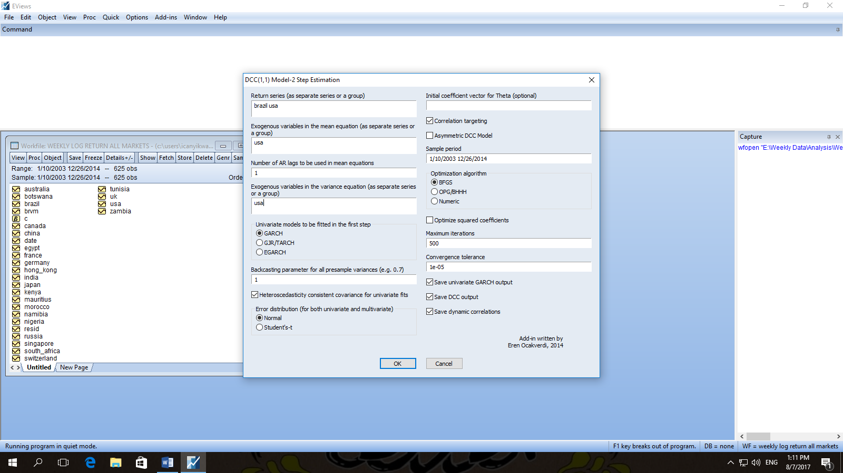

Screen shot when you run the test.


