This is how i did, first to import data i have delated the NA
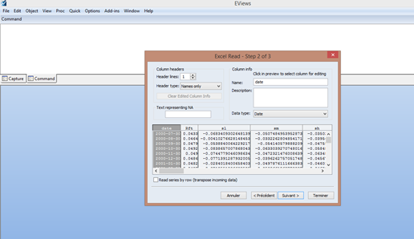

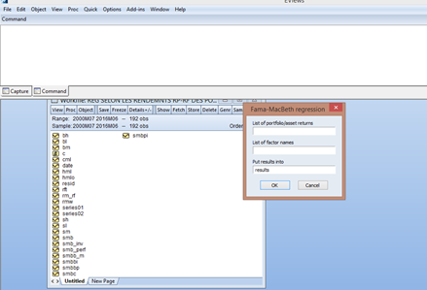

For the 3 factor model (rm-rf, smb hml) i have no problem and the results for gammas and betas are shown

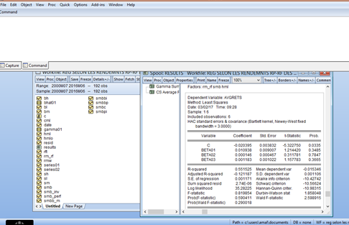

For the five factor model (rm-rf smb hml rmw cma) it does not work and i have this error message that says “ positive or non-negative argument to function expected in “RESULTS01 APPEND CSAVG”

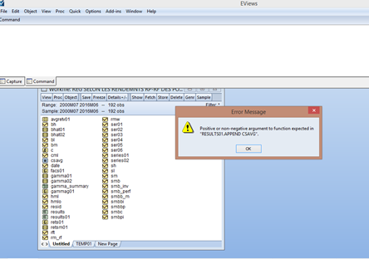

I have the results for gammas but not for betas



