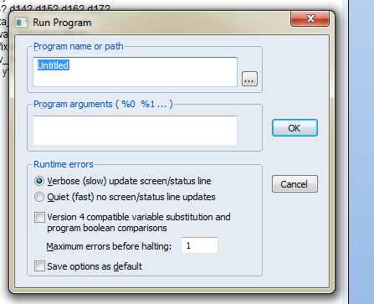
1. Could you explain to me how to fill the display above ?
2. What is function of each part ?
Thank you very much.

