Hi every one.
I have 2 questions. Please refer to the attachment.
question 1:in x12 options, I choose” Arima spec” and next “select from file”(as below)

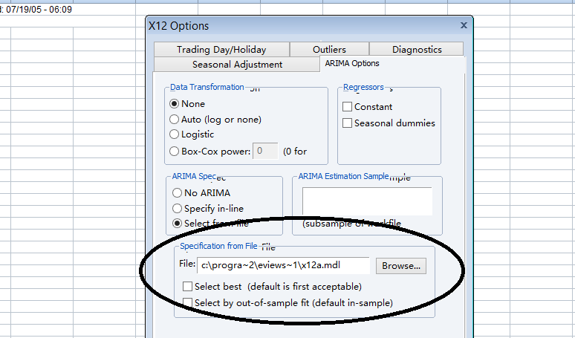
Why are there the tips?
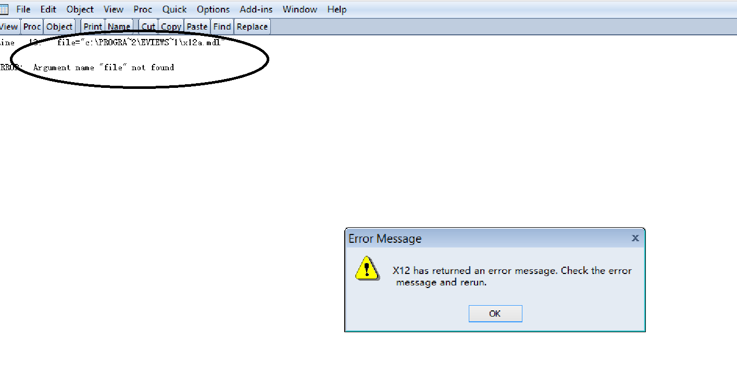

In fact,x12a.mdl is just there. What happened?
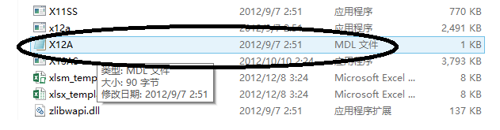
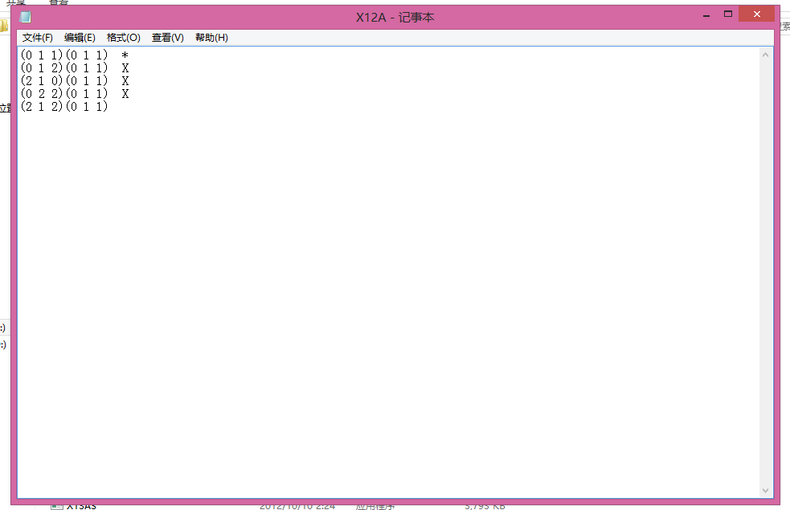
question 2:
If I want to create a holiday dummy variable , how files should be entered? Is it correct in .txt as below?

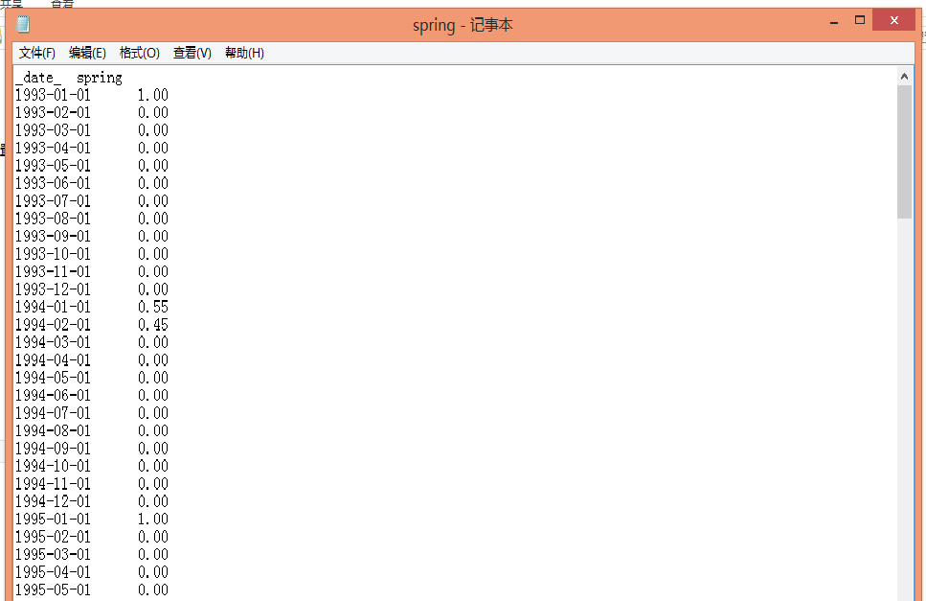

I would highly appreciate if any of you could help me.

