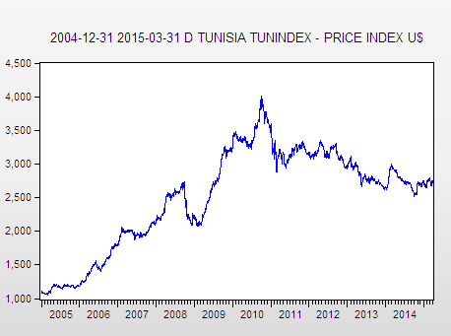

Throughout the study, the returns are calculated Rt = 100 × In (Pt / Pt-1) where Pt is the daily closing price, Rt is the daily log-returns.

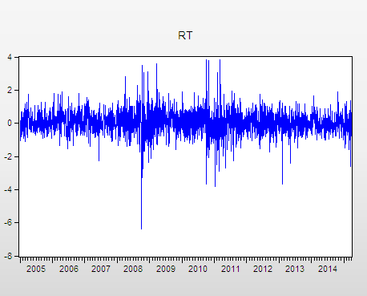

 | RT
Mean | 0.033449
Median | 0.030448
Maximum | 3.839129
Minimum | -6.357502
Std. Dev. | 0.708247
Skewness | -0.263471
Kurtosis | 9.067576
Jarque-Bera | 4129.704
Probability | 0.000000
Sum | 89.37461
Sum Sq. Dev. | 1339.811
Observations | 2672

the plot shows a clustering of larger return volatility,This means that the stock markets are characterized by volatility clustering, i.e. large (small) volatility tends to be followed by large (small) volatility, revealing the presence of heteroskedasticity.

1-stationarity tests :

ADF

Null Hypothesis: LM has a unit root
Exogenous: Constant
Lag Length: 0 (Automatic - based on SIC, maxlag=27)
 |  |  | t-Statistic | Prob.*
Augmented Dickey-Fuller test statistic |  |  | -44.91389 | 0.0001
Test critical values: | 1% level |  | -3.432606
 | 5% level |  | -2.862422
 | 10% level |  | -2.567285
*MacKinnon (1996) one-sided p-values.
Augmented Dickey-Fuller Test Equation
Dependent Variable: D(LM)
Method: Least Squares
Date: 12/19/15 Time: 14:56
Sample (adjusted): 1/04/2005 3/31/2015
Included observations: 2671 after adjustments
Variable | Coefficient | Std. Error | t-Statistic | Prob.
LM(-1) | -0.861140 | 0.019173 | -44.91389 | 0.0000
C | 0.028885 | 0.013591 | 2.125288 | 0.0337
R-squared | 0.430462 | Mean dependent var |  | -0.000186
Adjusted R-squared | 0.430249 | S.D. dependent var |  | 0.929525
S.E. of regression | 0.701622 | Akaike info criterion |  | 2.129906
Sum squared resid | 1313.879 | Schwarz criterion |  | 2.134316
Log likelihood | -2842.489 | Hannan-Quinn criter. |  | 2.131502
F-statistic | 2017.258 | Durbin-Watson stat |  | 2.013845
Prob(F-statistic) | 0.000000

INTERPRETATION :0.0001< 0,05 reject H0 so The series of returns is stationary

2- ARIMA
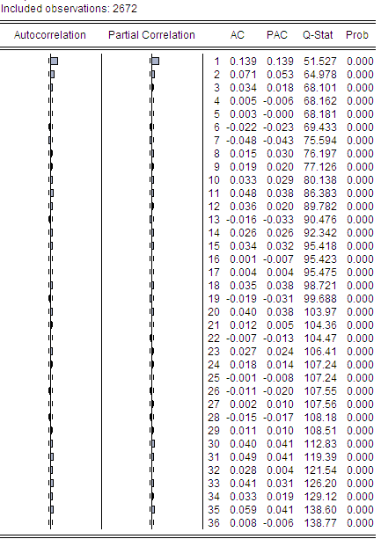

Interpretations

- Plot (PACF) :Significant at lags1, 2 : AR(2)

- Plot (ACF) :Significant at lags1, 2 : MA(2)

So , we must choose the best combinaison :

Eviews command : Estimate equation : Rt c ….
- AR(1) MA(1)
- AR(1) MA(2)
- AR(2) MA(1)
- AR(2) MA(2)

Dependent Variable: RT
Method: Least Squares
Date: 12/21/15 Time: 14:29
Sample (adjusted): 1/04/2005 3/31/2015
Included observations: 2671 after adjustments
Convergence achieved after 10 iterations
MA Backcast: 1/03/2005
Variable | Coefficient | Std. Error | t-Statistic | Prob.
C | 0.033853 | 0.017021 | 1.988903 | 0.0468
AR(1) | 0.485055 | 0.105348 | 4.604320 | 0.0000
MA(1) | -0.353614 | 0.112697 | -3.137744 | 0.0017
R-squared | 0.022432 | Mean dependent var |  | 0.033573
Adjusted R-squared | 0.021699 | S.D. dependent var |  | 0.708351
S.E. of regression | 0.700623 | Akaike info criterion |  | 2.127429
Sum squared resid | 1309.648 | Schwarz criterion |  | 2.134045
Log likelihood | -2838.182 | Hannan-Quinn criter. |  | 2.129823
F-statistic | 30.61083 | Durbin-Watson stat |  | 2.000863
Prob(F-statistic) | 0.000000
Inverted AR Roots | .49
Inverted MA Roots | .35

Dependent Variable: RT
Method: Least Squares
Date: 12/21/15 Time: 14:31
Sample (adjusted): 1/04/2005 3/31/2015
Included observations: 2671 after adjustments
Convergence achieved after 2 iterations
MA Backcast: 12/31/2004 1/03/2005
Variable | Coefficient | Std. Error | t-Statistic | Prob.
C | 0.033527 | 0.016411 | 2.042930 | 0.0412
AR(1) | 0.130309 | 0.019355 | 6.732698 | 0.0000
MA(2) | 0.052495 | 0.019387 | 2.707782 | 0.0068
R-squared | 0.021719 | Mean dependent var |  | 0.033573
Adjusted R-squared | 0.020986 | S.D. dependent var |  | 0.708351
S.E. of regression | 0.700878 | Akaike info criterion |  | 2.128158
Sum squared resid | 1310.603 | Schwarz criterion |  | 2.134774
Log likelihood | -2839.155 | Hannan-Quinn criter. |  | 2.130552
F-statistic | 29.61643 | Durbin-Watson stat |  | 1.998411
Prob(F-statistic) | 0.000000
Inverted AR Roots | .13
Dependent Variable: RT
Method: Least Squares
Date: 12/21/15 Time: 14:32
Sample (adjusted): 1/05/2005 3/31/2015
Included observations: 2670 after adjustments
Convergence achieved after 5 iterations
MA Backcast: 1/04/2005
Variable | Coefficient | Std. Error | t-Statistic | Prob.
C | 0.033960 | 0.016450 | 2.064432 | 0.0391
AR(2) | 0.067573 | 0.019478 | 3.469209 | 0.0005
MA(1) | 0.131160 | 0.019362 | 6.773962 | 0.0000
R-squared | 0.021719 | Mean dependent var |  | 0.033983
Adjusted R-squared | 0.020986 | S.D. dependent var |  | 0.708167
S.E. of regression | 0.700697 | Akaike info criterion |  | 2.127640
Sum squared resid | 1309.433 | Schwarz criterion |  | 2.134257
Log likelihood | -2837.399 | Hannan-Quinn criter. |  | 2.130034
F-statistic | 29.60571 | Durbin-Watson stat |  | 2.000471
Prob(F-statistic) | 0.000000
Inverted AR Roots | .26 | -.26
Inverted MA Roots | -.13

Dependent Variable: RT
Method: Least Squares
Date: 12/21/15 Time: 14:33
Sample (adjusted): 1/05/2005 3/31/2015
Included observations: 2670 after adjustments
Convergence achieved after 3 iterations
MA Backcast: 1/03/2005 1/04/2005
Variable | Coefficient | Std. Error | t-Statistic | Prob.
C | 0.034010 | 0.014758 | 2.304519 | 0.0213
AR(2) | 0.107536 | 0.264021 | 0.407302 | 0.6838
MA(2) | -0.036929 | 0.265365 | -0.139163 | 0.8893
R-squared | 0.005061 | Mean dependent var |  | 0.033983
Adjusted R-squared | 0.004315 | S.D. dependent var |  | 0.708167
S.E. of regression | 0.706637 | Akaike info criterion |  | 2.144524
Sum squared resid | 1331.729 | Schwarz criterion |  | 2.151142
Log likelihood | -2859.940 | Hannan-Quinn criter. |  | 2.146919
F-statistic | 6.783531 | Durbin-Watson stat |  | 1.743780
Prob(F-statistic) | 0.001152
Inverted AR Roots | .33 | -.33
Inverted MA Roots | .19 | -.19
Interpretation : we remark that the AIC of ARMA (1,1) is the smallest , so we choose it

- Q stat
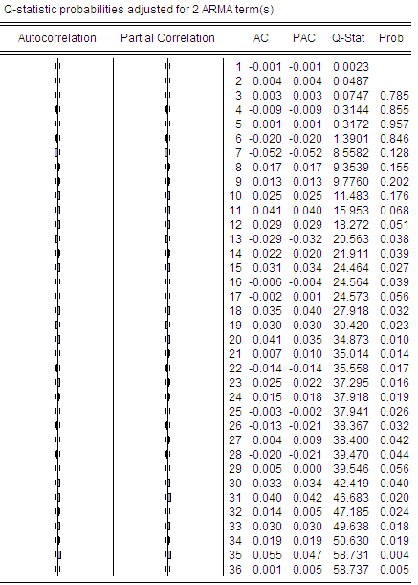

some values are sig and others aren’t ? should I difference the series again ? what Q stat should I choose to Interpret ??
Tests for conditional heteroscedasticity

Breusch-Godfrey Serial Correlation LM Test:
F-statistic | 0.045918 | Prob. F(2,2666) |  | 0.9551
Obs*R-squared | 0.091895 | Prob. Chi-Square(2) |  | 0.9551
Test Equation:
Dependent Variable: RESID
Method: Least Squares
Date: 12/21/15 Time: 14:42
Sample: 1/04/2005 3/31/2015
Included observations: 2671
Presample missing value lagged residuals set to zero.
Variable | Coefficient | Std. Error | t-Statistic | Prob.
C | -1.19E-06 | 0.017029 | -6.97E-05 | 0.9999
AR(1) | -0.010333 | 0.318937 | -0.032400 | 0.9742
MA(1) | -0.009425 | 0.638412 | -0.014764 | 0.9882
RESID(-1) | 0.018836 | 0.336068 | 0.056049 | 0.9553
RESID(-2) | 0.012510 | 0.084944 | 0.147268 | 0.8829
R-squared | 0.000034 | Mean dependent var |  | -0.000143
Adjusted R-squared | -0.001466 | S.D. dependent var |  | 0.700361
S.E. of regression | 0.700874 | Akaike info criterion |  | 2.128892
Sum squared resid | 1309.603 | Schwarz criterion |  | 2.139918
Log likelihood | -2838.136 | Hannan-Quinn criter. |  | 2.132882
F-statistic | 0.022932 | Durbin-Watson stat |  | 1.999148
Prob(F-statistic) | 0.998979
interpretation :p value > 5% : Reject H0 => so the series hasn’t a serial correlation

