I created the following matrix :
mata
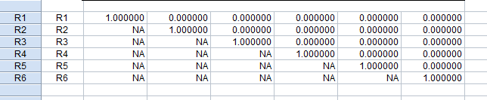
matb
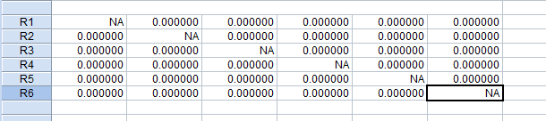
Then, I do the VAR system
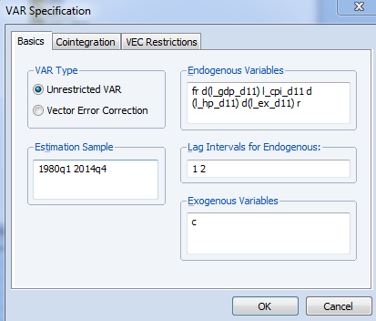
After that I estimated the structural factorizations:
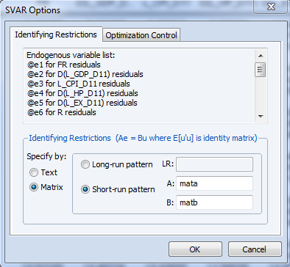
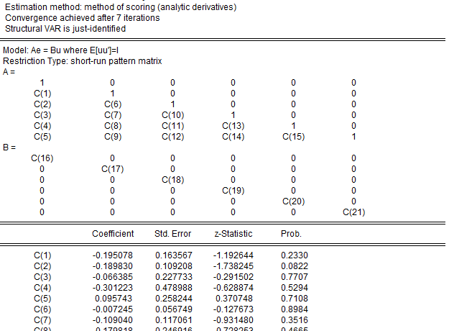

But I would like to add the following restrictions:


