Dear, ALL:
I am master student in Hunan university – China.Frist of all,I would like thank MR.Yashar Tarverdi Mamaghani to give us code of ARDL Model.
My model My model as Follows:
LGDP=LFDI +LGFC +LIKG + LIIG+ LICG +LLF +D1
The variable are Integrated I(0) and I(1) , so l must using ARDL but I have a big problem that is :
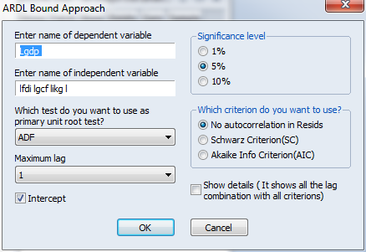
I could not entered mor than tow variable and 16 Characters in the e code of ARDl like this picture :
This

After Insert just three independent variables and press ok the error message appear as a follow picture
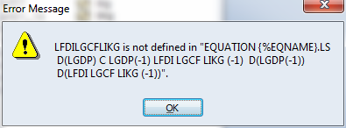

Please any friend can help to extend code of ARDL in order to carry out my model , and solved my problem , also if u have any book or materials related with ARDL please send it to me.
Sincerely
: Abdo Ali

