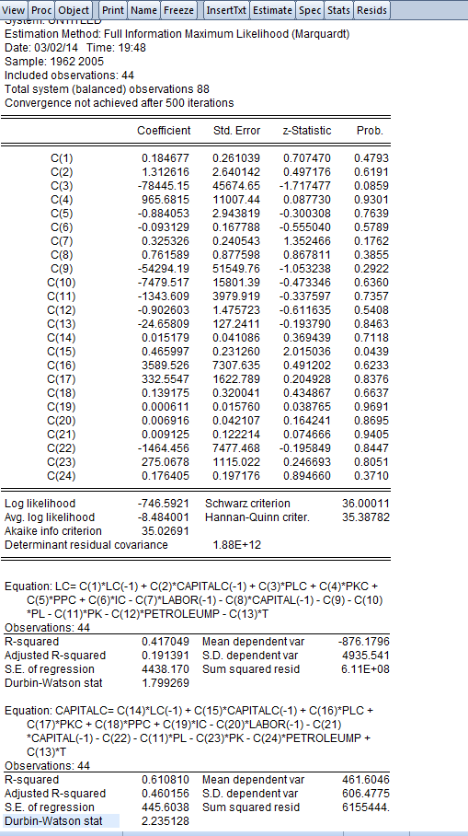

$\left[\begin{matrix}∆sl_{t} \\ ∆sk_{t} \\ ∆sh_{t}\end{matrix}\right]$ = $\left[\begin{matrix}α_{11} & α_{12} \\ α_{21} & α_{22} \\ α_{31} & α_{32}\end{matrix}\right]$ $\left[\begin{matrix}∆sl_{t-1} \\ ∆sk_{t-1}\end{matrix}\right]$ + $\left[\left[\begin{matrix}β_{11} & ⋯ & β_{14} \\ ⋮ & ⋱ & ⋮ \\ β_{31} & ⋯ & β_{34}\end{matrix}\right]\right]\left[\begin{matrix}\begin{matrix}∆w \\ ∆q\end{matrix} \\ \begin{matrix}∆p_{h} \\ ∆y\end{matrix}\end{matrix}\right]$ - $\left[\begin{matrix}k_{11} & k_{12} \\ k_{21} & k_{22} \\ k_{31} & k_{32}\end{matrix}\right]\left[\begin{matrix}sl_{t-1} \\ sk_{t-1}\end{matrix}\right]$ - $\left[\begin{matrix}π_{10} & ⋯ & π_{14} \\ ⋮ & ⋱ & ⋮ \\ π_{30} & ⋯ & π_{34}\end{matrix}\right]$ $\left[\begin{matrix}\begin{matrix}1 \\ w \\ q\end{matrix} \\ p_{h} \\ T\end{matrix}\right]$ + $\left[\begin{matrix}ε_{1t} \\ ε_{2t}\end{matrix}\right]$, (16)

Restricted form: steady state
$\left[\begin{matrix}sl_{} \\ sk_{} \\ sh_{}\end{matrix}\right]=\left[\begin{matrix}{\begin{matrix}-54294.19 & -7479.517 & -1343.609\end{matrix}}_{} & -0.902603 & -24.65809 \\ \begin{matrix}-1464.456 & -1343.609 & 275.0678\end{matrix} & 0.176405 & 24.65809 \\ \begin{matrix}55759.646 & 8823.126 & 1068.5412\end{matrix} & 0.726198 & 0\end{matrix}\right]$ $\left[\begin{matrix}\begin{matrix}1 \\ w \\ q\end{matrix} \\ p_{h} \\ T\end{matrix}\right]$

Dynamics
$\left[\begin{matrix}∆sl_{t} \\ ∆sk_{t} \\ ∆sh_{t}\end{matrix}\right]$ = $\left[\begin{matrix}0.184677 & 1.312616 \\ 0.015179 & 0.465997 \\ & \end{matrix}\right]$ $\left[\begin{matrix}∆sl_{t-1} \\ \begin{matrix}∆sk_{t-1} \\ ∆sh_{t-1}\end{matrix}\end{matrix}\right]$ + $\left[\left[\begin{matrix}-78445.15 & \begin{matrix}965.6815 & -0.884053\end{matrix} & -0.093129 \\ 3589.526 & \begin{matrix}332.5547 & 0.139175\end{matrix} & 0.000611 \\ & & \end{matrix}\right]\right]\left[\begin{matrix}\begin{matrix}∆w_{t} \\ ∆q_{t}\end{matrix} \\ \begin{matrix}∆p_{ht} \\ ∆y_{t}\end{matrix}\end{matrix}\right]$ - $\left[\begin{matrix}0.325326 & 0.761589 \\ 0..006916 & 0.009125 \\ & \end{matrix}\right]\left[\begin{matrix}\begin{matrix}sl_{t-1} \\ sk_{t-1}\end{matrix} \\ sh_{t-1}\end{matrix}\right]$

And from the above functions how to use EViews to calculate out the elasticities similar to the following. I am not familiar with EViews. Please do give me a clue.


