I have tested the function 16 and get the results. I am not familiar with EViews and may I ask whether my results are correctly.
First, let me attach the functions and EViews results.

Functions for testing
$\left[\begin{matrix}∆sl_{t} \\ ∆sk_{t} \\ ∆sh_{t}\end{matrix}\right]$ = $\left[\begin{matrix}α_{11} & α_{12} \\ α_{21} & α_{22} \\ α_{31} & α_{32}\end{matrix}\right]$ $\left[\begin{matrix}∆sl_{t-1} \\ ∆sk_{t-1}\end{matrix}\right]$ + $\left[\left[\begin{matrix}β_{11} & ⋯ & β_{14} \\ ⋮ & ⋱ & ⋮ \\ β_{31} & ⋯ & β_{34}\end{matrix}\right]\right]\left[\begin{matrix}\begin{matrix}∆w \\ ∆q\end{matrix} \\ \begin{matrix}∆p_{h} \\ ∆y\end{matrix}\end{matrix}\right]$ - $\left[\begin{matrix}k_{11} & k_{12} \\ k_{21} & k_{22} \\ k_{31} & k_{32}\end{matrix}\right]\left[\begin{matrix}sl_{t-1} \\ sk_{t-1}\end{matrix}\right]$ - $\left[\begin{matrix}π_{10} & ⋯ & π_{14} \\ ⋮ & ⋱ & ⋮ \\ π_{30} & ⋯ & π_{34}\end{matrix}\right]$ $\left[\begin{matrix}\begin{matrix}1 \\ w \\ q\end{matrix} \\ p_{h} \\ T\end{matrix}\right]$ + $\left[\begin{matrix}ε_{1t} \\ ε_{2t}\end{matrix}\right]$, (16)
$$π_{12}=π_{21}$$
$$π_{14}=-π_{24}$$
And other restrictions are related to Holly’s paper (attached in the email)

The results are in the following page.
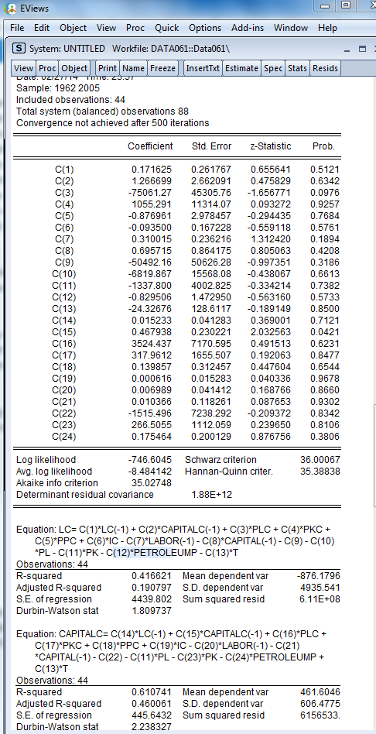

And besides the results, I have tried many ways for the partial elasticities. If the results are feasible, how can we reach the similar partial elasticities on page 121. Would you like to give me some suggestions? Thank you very much.
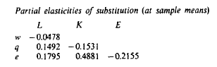
The above is on page 121 of Holly’s paper (in the following page)


