14- years panel with 52 weekly returns for each company.
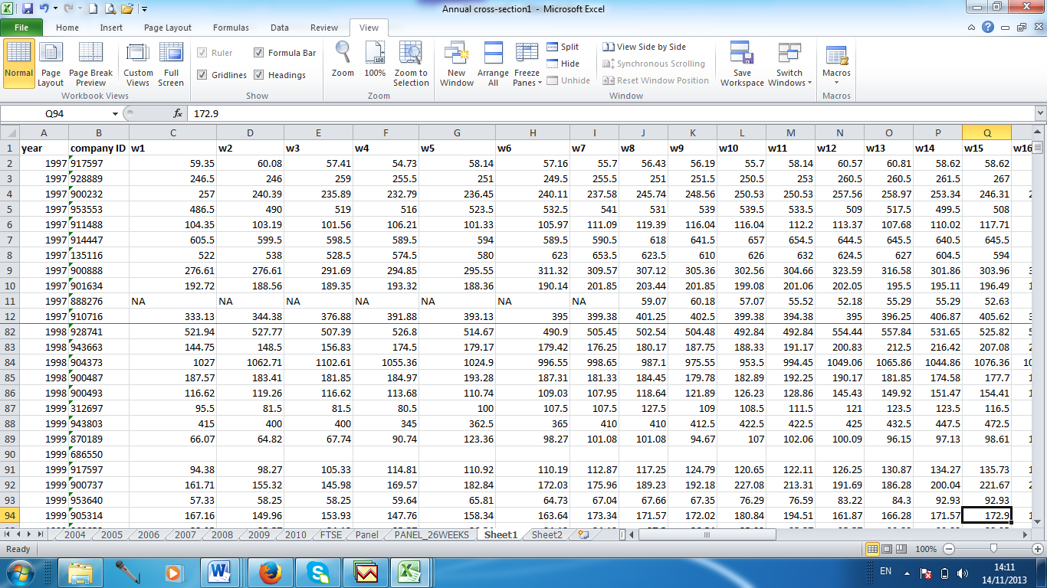

Annual cross-section with weekly returns:
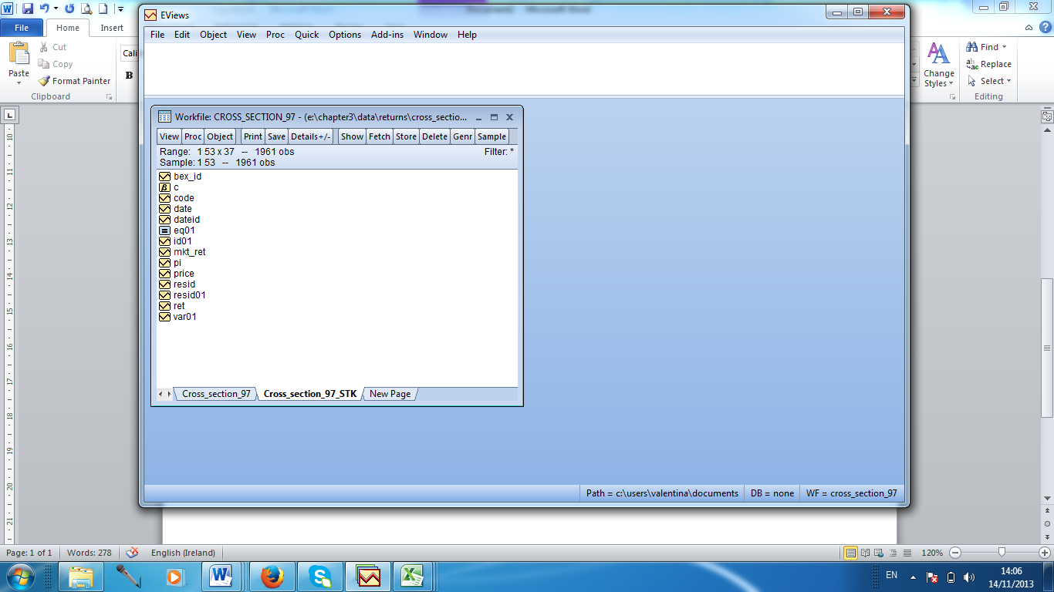

Annual cross-section with weekly returns and weekly index returns:


