Note I’m using two screens and the left screen is the eviews files. Build is Apr 16 2013. Serial 80K00168.

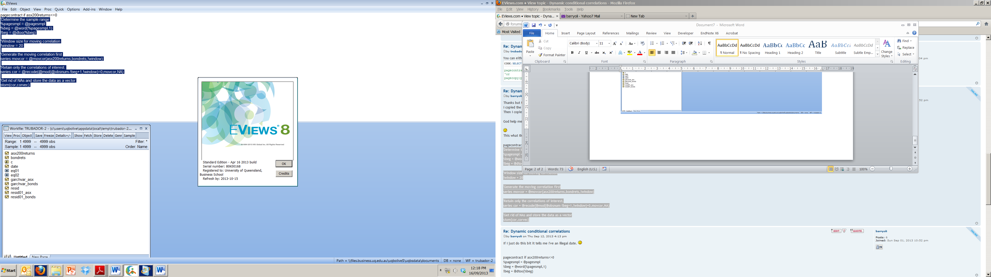

Open trubador.wf1 and copy “pagecontract if asx200returns<>0” into program window press return. Result
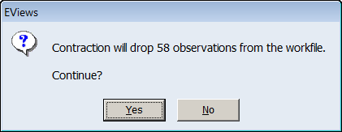
Click yes
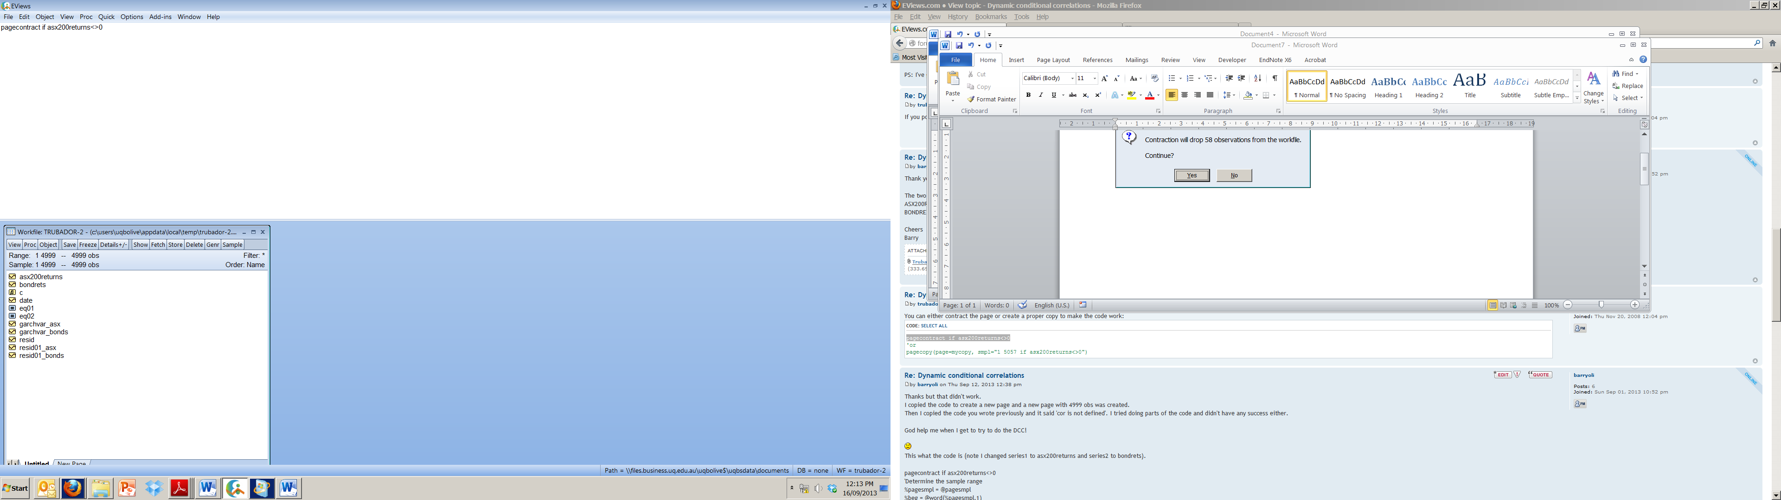

Copy program:
'Determine the sample range
%pagesmpl = @pagesmpl
%beg = @word(%pagesmpl,1)
!beg = @dtoo(%beg)

'Window size for moving correlation
!window = 20

'Generate the moving correlation first
series movcor = @movcor(asx200returns,bondrets,!window)

'Retain only the correlations of interest.
series cor = @recode(@mod(@obsnum-!beg+1,!window)=0,movcor,NA)

'Get rid of NAs and store the data as a vector
stom(cor,corvec)

press return:
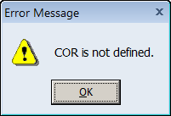
Click ok:


